20 Common Homonyms

- 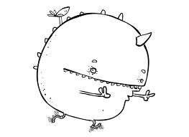 ate/eight
- bear/bare
- be/bee
- blew/blue
- chews/choose
- clothes/close
- eye/I
- flower/flour
- hare/hair
- nose/knows
- maid/made
- meet/meat
- to/too/two
- waist/waste
- weak/week
- sea/see
- tacks/tax
- hour/our
- whole/hole
- there/their/they’re

