20 Common Idioms

All ears
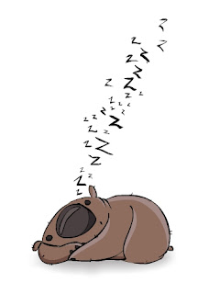If someone says they're all ears, they are very interested in hearing about something.
As cool as a cucumber
If someone is as cool as a cucumber, they don't get worried by anything.
Be all ears
If you are all ears, you are very eager to hear what someone has to say.
Break a leg
This idiom is a way of wishing someone good luck.
Busy as a bee
If you are as busy as a bee, you are very busy indeed.
Cold feet
If you get cold feet about something, you lose the courage to do it.
Could eat a horse
If you are very hungry, you could eat a horse.
Doggy bag
If you ask for a doggy bag in a restaurant, they will pack the food you haven't eaten for you to take home.
Early bird catches the worm
The early bird catches the worm means that if you start something early, you stand a better chance of success.
Easy as pie
If something is easy as pie, it is very easy indeed.
Feeling blue
If you feel blue, you are feeling unwell, mainly associated with depression or unhappiness.
Give me a hand
If someone gives you a hand, they help you.
Go nuts
If someone goes nuts, they get excited over something.
Hold your horses
If someone tells you to hold your horses, you are doing something too fast and they would like you to slow down.
Just in the nick of time
If you do something in the nick of time, you just manage to do it just in time, with seconds to spare.
Knock your socks off
If something knocks your socks off, it amazes and surprises you, usually in a positive way.
Made of money
If you are made of money, you have a lot of money.
Pain in the neck
If someone is very annoying and always disturbing you, they are a pain in the neck.
Put your foot in your mouth
If you put your foot in your mouth, you say something stupid or embarrassing.
Quiet as a mouse
If someone's as quiet as a mouse, they make absolutely no noise.

