Speech Sticks

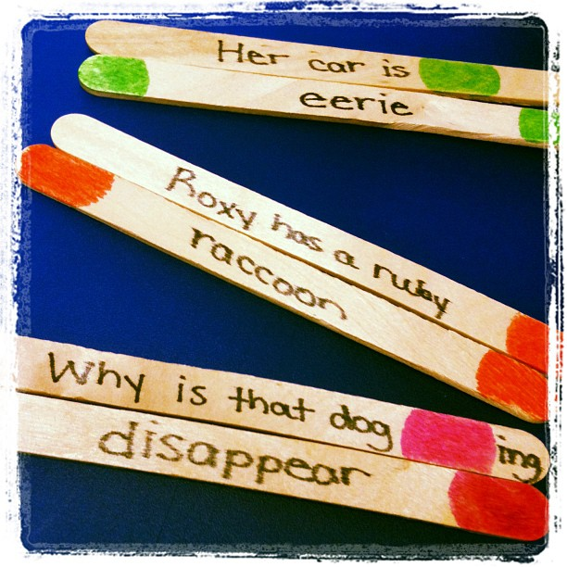

What you will need:
- 40 sticks for each artic sound - for carrier phrases.
- 30 sticks for each position of a sound - 10 nouns, 10 adjectives, 10 verbs for each position of each sound.
- Sharpie
- Paint/Markers for color-coordinating

What to do:
Take your 40 sticks and write carrier phrases on them (list of these will be provided below as they are completed). Use your marker/paint to identify what type of word will fill in the blank. I used red for nouns, green for adjectives and pink for verbs. (You will use the same color to identify the word sticks) Then write words on the front and back of 10 sticks per part of speech per sound position (e.g. 10 sticks with initial /r/ nouns on each side - total of 20 initial /r/ nouns).

How to Play:
Students can play individually or with partners/group. The student draws a carrier phrase and identifies which type of word stick they will need. They then draw a word stick and match it to the carrier phrase. Then they say the sentence the number of times you would like. * Create other phrases and word lists for the sound your child is working on.

/r/ phrases
The beaver build a/an (noun)

Morris is a (noun)

I will run in a (noun)

I admire my (noun)

A parrot is a (noun)

Please eat the (noun)

The forest is full of (noun)

Please pass the (noun)

She will rake the (noun)

Can you reach the (noun)

(Noun)s like to eat cheese.

He puts quarters in his (noun).

Gary flew the (noun).

Roxy has a ruby (noun)

Why is that dog (verb)ing?

My mouth is (verb)ing.

The giraffe began to (verb)

Teresa is (verb)ing the candy

(Verb) and rest awhile

There is lots of time to (verb)

Go outside and (verb)

Her dad uses a razor to (verb)

/r/ phrases:

Are they (verb)ing?

We (verb) in our spare time.

Her car is (verb)ing.

Which dinosaur is the most (adjective)?

The rocket is very (adjective)

That is so (adjective)

It’s very (adjective) outside

We left the door (adjective)

Rachel’s room is (adjective)

This flower smells (adjective)

This road is (adjective)

My mother is (adjective)

Your beard is (adjective)

I am very (adjective)

The flowers are very (adjective)

An alligator has (adjective) teeth

(Adjective) bananas taste good.

Her car is (adjective)

/s/ phrases

Sue can (verb) a song.

Cedar wood is very (adjective).

I will (verb) your (noun).

This horse has a (noun).

Let’s go (verb)ing.

Sam ate the (noun).

The sea tossed and (verb)ed.

This seat is (adjective).

Can you see the (noun)?

Silk feels (adjective).

This pickle is (adjective).

Is that suit (adjective)?

The sun set (adjective)ly.

The grasshopper is (adjective).

Be careful with the (noun).

Bring your bathing (noun).

The (noun) began to blossom.

I like classic (noun)s.

December was very (adjective).

Can you (verb) baseball?

Teresa will (verb) tonight.

She made the hat (verb).

(Verb) an essay about (noun)s.

We felt the (noun).

Don’t be too (adjective)y.

A bee is a/an (noun).

Can you (verb)?

That bus is (adjective).

Breakfast was very (adjective).

Janice likes (noun)(s).

Mice are (noun)(s).

(Noun) covered the house.

Thomas the tortoise will (verb).

Her niece is (adjective).

Did you notice the (noun)?

She owns her own (noun).

The goose and moose are (adjective).

Try to (verb) the answer.

Sol (verb)ed over a (noun).

Sand feels (adjective).

/r/ words:

Initial:

wrist
rock
rectangle
rattlesnake
room
radio
rice
roach
rabbit
raccoon

Nouns
rake
raft
rose
rain
radish
relish
rainbow
rash
rocket
robot

Adjectives
raw
rude
round
rainy
rapid
ridiculous
rinsed
ripped
rotten
ruined
risky
rough
wrinkled
wrecked
wrapped
ruffly
ruby red
rocky
rested
rich
race
rain
read
roast
rock
ruin
rush
wrap
write
react

Verbs
realize
refuse
recycle
relax
remind
remove
repeat
rescue
wreck
recite

Medial:

barrel
berry
camera
carrot
clarinet
giraffe
macaroni
parakeet
syrup
tarantula

Nouns
beard
cork
heart
worm
garbage
hairbrush
marshmallow
popcorn
lizard
cartoon
Adjectives
bored
slippery
dark
enormous
sharp
eerie
warm
horrible
weird
sparkling
allergic
scary
angry
furious
barefoot
imaginary
curly
furry
miserable
fierce
bark
snarl
squirt
gargle
somersault
learn
warn
twirl
argue
sharpen

Verbs
arrest
borrow
carry
embarrass
erase
marry
worry
irritate
decorate
barbeque

Final:

bear
car
chair
fur
tar
wire
tire
apple core
candy bar
dinosaur

Nouns
meteor
nightmare
souvenir
oyster
alligator
blister
cucumber
diaper
gopher
monster
Adjectives
better
clever
eager
miniature
muscular
tender
silver
clear
fair
far
poor
spare
wire
bizarre
sapphire
sincere
unfair
square
near
luckier
bore
cheer
dare
glare
hear
pour
purr
score
scare
admire

Verbs
appear
disappear
explore
ignore
volunteer
capture
discover
glitter
slobber
whisper

/s/ words:

Initial:

sack
salt
seal
soap
sock
sun
ceiling
celery
cereal
saddle

Nouns
salami
salmon
sea gull
seaweed
siren
soccer ball
soda
submarine
sundae
syrup
sad
sick
soft
sour
sore
cinnamon
salty
secret
selfish
silent

Adjectives
silly
silver
soaking
soggy
solid
sunburned
sunny
cement
soapy
sudden
sail
search
sell
send
serve
sing
soak
surf
celebrate
salute

Verbs
select
separate
signal
subtract
suggest
support
save
say
set
sip

Medial:

basketball
costume
hamster
lobster
monster
mosquito
ostrich
pizza
pretzel
rooster

Nouns
telescope
bicycle
dinosaur
eraser
fossil
grasshopper
icicle
lasso
muscle
whistle
bossy
fussy
glistening
glossy
grassy
impossible
juicy
messy
mossy
icy

Adjectives
asleep
crispy
elastic
exciting
extinct
fancy
frisky
muscular
rusty
upside-down
chasing
decide
listen
receive
recite
recycle
accept
answer
describe
destroy

Verbs
escape
exchange
expect
explode
inspect
question
rescue
whisper
whistle
wrestle

Final:

base
dice
face
geese
juice
rice
address
caboose
cactus
hippopotamus

Nouns
lettuce
octopus
tortoise
mailbox
walrus
ambulance
fox
compass
platypus
pillowcase
Adjectives
brass
ridiculous
loose
toothless
mess
complex
adventurous
deluxe
anxious
false
contagious
tense
courageous
glass
dangerous
cautious
fabulous
hilarious
nervous
jealous
boss
chase
dress
embarrass
floss
fuss
grease
guess
hiss
race

Verbs
toss
notice
focus
crease
cross
mess
pass
place
press
trace

